Physics 20 Lesson 20

Uniform Circular Motion – Vertical Plane

# Vertical uniform circular motion

Refer to Pearson pages 260 to 264 for a discussion about circular motion.

So far we have considered uniform circular motion problems which have involved only one applied force and the plane of motion has been horizontal. What if we start to rotate something in a vertical plane? If the object is rotating in the vertical plane, rather than horizontally, there are now two forces acting: the force of gravity (weight) and a tension or normal force, depending on the situation. Objects moving in a vertical circle (vertical plane) create unique problems because the weight plays different roles at different points in the circle.

If we define direction as **(+) for forces acting toward the center of the circle** and **(–) for forces acting away from the center of the circle**, consider the two situations below

### Top of the circle:

At the top of the circle, the weight is acting *toward* the center of the circle. The tension force is relatively small. Thus:



v

v

FT

Fg

Fc

### Bottom of the circle:

At the bottom of the circle, the weight is acting *away* from the centre of the circle. The tension force required is greater. Thus:



FT

Fc

v

Fg

v

Uniform circular motion *requires* a constant centripetal force. Thus, if the motion is to remain uniform, the tension force must change from the top of the circle to the bottom of the circle. This is due to the fact that the direction of the gravitational force (weight) remains downward throughout the motion.

A 1.8 kg object is swung from the end of a 0.50 m string in a vertical circle. If the time of revolution is 1.2 s, what is the tension in the string

A. at the top of the circle?

B. at the bottom of the circle?

For uniform circular motion the centripetal force is constant, although its direction changes. We can calculate Fc from the information in the problem.



We can also calculate Fg

Fg = mg = 1.8 kg(9.81 m/s2) = 17.66 N

A. at the top



Fg

v

FT = **7.01 N**

B. at the bottom



FT

Fg

v

FT = **42.33 N**



An object is swung in a vertical circle with a radius of 0.85 m. What is the minimum speed of the object so that it remains in circular motion?

The position where the minimum speed can be calculated is at the top of the circle. If the speed is less than the minimum, the object will fall out of circular motion at the top. Thus, at the minimum speed, gravity will be the only force required to maintain the circular motion.

v



(mass cancels)

v = **2.89 m/s**

# Practice problems

1. Mr. Licht is rotating a pail of water with a mass of 2.00 kg in a vertical circle. Mr. Licht’s arm is 70 cm long.

A. If the pail has a speed of 3.00 m/s, what is the tension in Mr. Licht’s arm:

i. At the top of the swing? (6.09 N)

ii. At the bottom of the swing? (45.3 N)

2. What is the minimum speed required so that a roller coaster car will safely go around a vertical loop which has a radius of 5.0 m? (7.0 m/s)

# Hand-in assignment

1. For each situation below, draw accurate free-body diagrams showing all forces acting on the rock.

B. Tied to a post and moving in a circle at constant speed on a frictionless horizontal surface. Coming straight out of the paper.

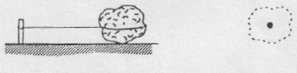

A. Swinging on a rope, at lowest position. No friction.

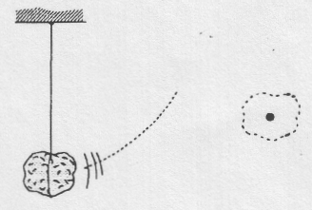

D. Swinging on a rope. No friction.

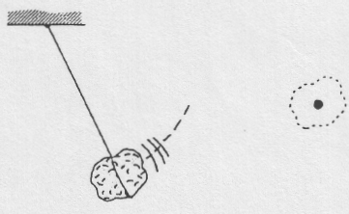

C. Tied to point A by a string. Moving in a horizontal circle at constant speed. Not resting on a solid surface. No friction. Coming straight out of the paper.

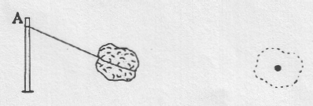

F. Riding on a horizontal disk that is rotating at constant speed about its vertical axis. Friction prevents rock from sliding. Rock is moving straight out of the paper.

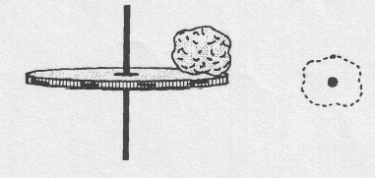

E. Swinging on a rope, at the top of a vertical circle.

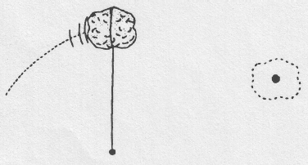

2. You are riding your bike on a track that forms a vertical circular loop. If the diameter of the loop is 7.0 m, how fast would you have to be travelling when you reached the top of the loop so that you would not fall? (5.86 m/s)

3. You are rotating a bucket of water in a vertical circle. Assuming that the radius of the rotation of the water is 0.95 m, what is the minimum velocity of the bucket at the top of its swing if the water is not to spill? (3.05 m/s)

4. A student has a weight of 655 N. While riding on a roller-coaster this same student has an apparent weight of 1.96 x 103 N at the bottom of the dip that has a radius of 18.0 m. What is the speed of the roller-coaster? (18.76 m/s)

5. A string requires a 186 N force in order to break. A 1.50 kg mass is tied to this string and whirled in a vertical circle with a radius of 1.90 m. What is the maximum speed that this mass can be whirled without breaking the string?

(14.73 m/s)

6. A 2.2 kg object is whirled in a vertical circle whose radius is 1.0 m. If the time of one revolution is 0.97 s, what is the tension in the string (assume uniform speed)

(a) when it is at the top? (70.7 N)

(b) when it is at the bottom? (113.9 N)